Arjun Mahajan
20bct0295

-STORY
https://public.tableau.com/app/profile/arjun.mahajan8137/viz/sales_datastory/Story1?publish=yes

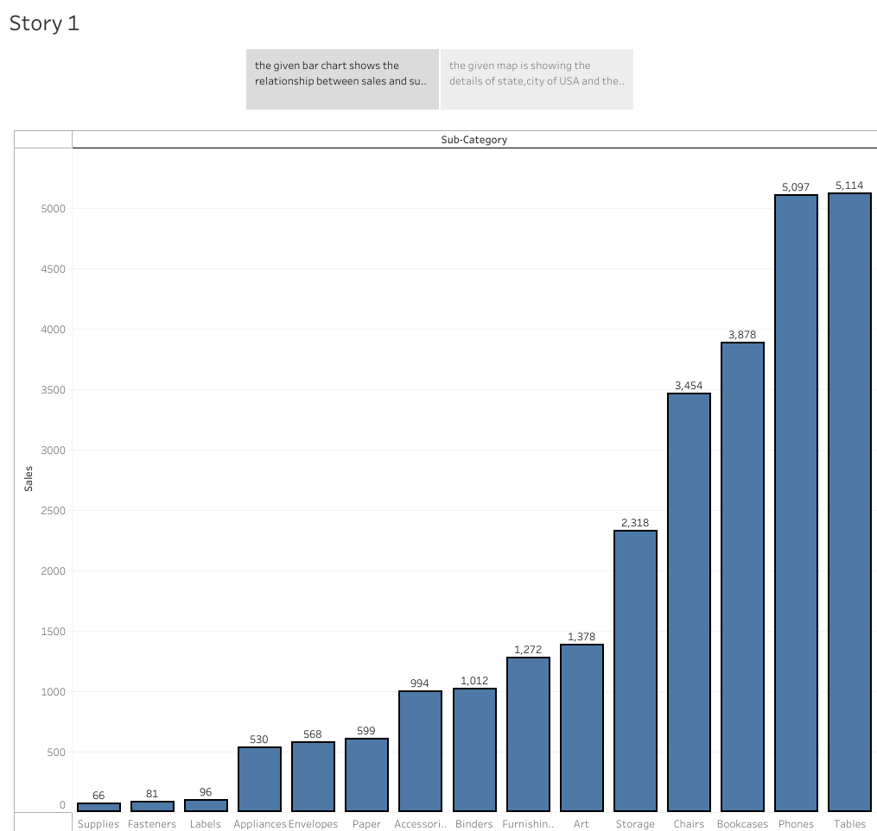
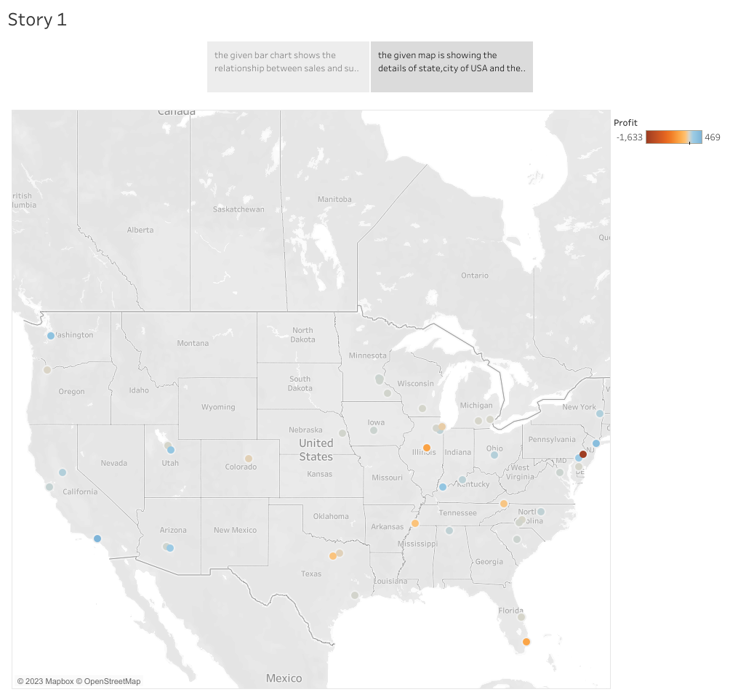

-dashboard
https://public.tableau.com/app/profile/arjun.mahajan8137/viz/sales_data_16860618418540/Dashboard1?publish=yes

